BCB 444/544
Homework 3 (20pts) Name _________________________________________
Due Mon Oct 8 by 5 pm
(please bring to class or deliver to MBB 106)

Objectives:
1. Practice using hidden Markov models to compute probabilities

Notes: You may work together on these problems, but each student must submit answers in his/her own words.
It's always best to show all of your calculations & intermediate steps.

Introduction:
We learned about hidden Markov models in class, but its difficult to really understand how they work until you have some practice working with them. This homework will give you practice calculating probabilities from an HMM. It isn’t a bioinformatics example problem, but this model will be much easier to work through with by hand. You can write some code to handle the more complicated biological models on your own time. ☺

1. Consider the occasionally dishonest casino example discussed in class.

The system has 3 states:
B denotes the start state
F denotes the state when a fair die is used
L denotes the state when a loaded die used

The transition probabilities between these states are shown in the diagram.

The emission probabilities are:
for state F, e_{F}(1) = e_{F}(2) = … = e_{F(}6) = 1/6;
for state L, e_{L}(1) = e_{L}(2) = … = e_{L}(5) = 0.1, e_{L}(6) = 0.5
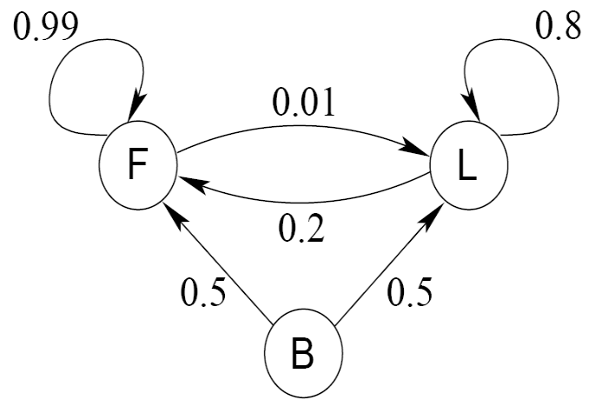

a) (5 pts) Calculate the probability:

What is the probability of the sequence (6, 1, 3) given that a fair die was used for all three rolls?

P(6,1,3) = P(B->F) * P(6|F) * P(F->F) * P(1|F) * P(F->F) * P(3|F) =
0.5 * ( 1/6) * 0.99 * (1/6) * 0.99 * (1/6) = 0.00227

What is the probability of the sequence (6, 1, 3) given that a loaded die was used for all three rolls?

P(6,1,3) = P(B->L) * P(6|L) * P(L->L) * P(1|L) * P(L->L) * P(3|L) =
0.5 * 0.5 * 0.8 * 0.1 * 0.8 * 0.1 = 0.0016

b) (10 pts) Finding the most likely path:

What is the most probable sequence of states, starting from state B, to produce the sequence of die tosses (6, 1, 3)? Show your work.

The sequence of states is B->F->F->F.

 |  | 6 | 1 | 3
B | 1 | 0 | 0 | 0
F | 0 | = 1/6 * max  {1 * 0.5,  0,  0}  = 1/6 * 0.5 = 1/12 | = 1/6 * max  {0,  1/12 * 0.99,  0.25 * 0.2}  = 1/6 * 1/12 * 0.99  = 0.01375 | = 1/6 * max  {0,  0.01375 * 0.99,  0.02 * 0.2}  = 1/6 * 0.01375 * 0.99  = 0.00227
L | 0 | = 1/2 * max  {1 * 0.5,  0,  0}  = 1/2 * 0.5 = 1/4 | = 0.1 * max  {0,  1/12 * 0.01,  0.25 * 0.8}  = 0.1 * 0.25 * 0.8  = 0.02 | = 0.1 * max  {0,  0.01375 * 0.01,  0.02 * 0.8}  = 0.1 * 0.02 * 0.8  = 0.0016

PLEASE NOTE that traceback is NOT necessarily from lower right corner to upper left (per DP) with Viterbi (this was a mistake in Xiong textbook!) Traceback begins in cell with highest probability in the last column, which corresponds to the last die in the sequence. Because of this error and confusion associated with it, we did not deduct points for starting at 0.0016, as long as traceback was otherwise correct.
c) (5 pts) Finding the total probability of an observed sequence:

What is the total probability of the sequence (6, 1, 3)? Show your work.

 |  | 6 | 1 | 3
B | 1 | 0 | 0 | 0
F | 0 | = 1/6 * sum  {1 * 0.5,  0,  0}  = 1/6 * 0.5 = 1/12 | = 1/6 * sum  {0,  1/12 * 0.99,  0.25 * 0.2}  = 1/6 * (0.0825 + 0.05)  = 0.022083 | = 1/6 * sum  {0,  0.022083 * 0.99,  0.020083 * 0.2}  = 1/6 * (0.02186217 + 0.0040166)  = 0.004313
L | 0 | = 1/2 * sum {1*0.5,  0,  0}  = 1/2 * 0.5 = 1/4 | = 0.1 * sum  {0,  1/12 * 0.01,  0.25 * 0.8}  = 0.1 * (0.00083 + 0.2)  = 0.020083 | = 0.1 * sum  {0,  0.022083 * 0.01,  0.0020083 * 0.8}  = 0.1 * (0.00022083 + 0.0160664)  = 0.001629

The total probability is 0 + 0.004313 + 0.001629 = 0.0059417

